CA2 Individual Report
Name | Ivan Ooi
Student Id | P2415534
Class | DAAA/FT/1B/04
Github Repository URL | https://github.com/ST0503-BED/bed-ca2-Life-Is-A-Scam
Github Account ID | Life-Is-A-Scam

For each competencies, find links to pull requests/commits/files that demonstrate the completion of the requirement. Replace each “?” with your Self Rating.
For Self Rating, you may rate yourself accordingly if you feel that you:
- Have little or no understanding. and did not attempt the requirement
- Have limited understanding of the specific competency
- Have basic understanding and only able to replicate examples from tutorials/practicals.
- Have adequate understanding and can extend from what you have learned to fulfil specifications.
- Have solid understanding in the specific competency, able work on the requirement without much references.
- Have excellent understanding and implemented the requirement according to latest industry guidelines, best practices and documentations.

Important
- You are require to provide for each competency:
  - A brief description
  - One or two of your best implementations with URL link to respective repository request/commits/files.
    - Below is an example of linking to specific script file
https://github.com/expressjs/express/blob/master/examples/static-files/index.js
  - The implementations may come from Section A or B.
- You are to ensure the hyperlink in this document works. Failure to do so will result in a 50% deduction of marks.
- You are to provide screenshots using POSTMAN to perform API test.

No. | Competencies | Describe What Was Done | Self Rating
1 | Backend Server | Using the token, I am able to make sure that the content seen by the user is theirs  https://github.com/ST0503-BED/bed-ca2-Life-Is-A-Scam/tree/main/src/controllers | 4/5
2 | Functionality | Most of the code works as expected  https://github.com/ST0503-BED/bed-ca2-Life-Is-A-Scam/blob/main/public/currentChallenge.html | 3/5
3 | Code Quality | I tried to use codes that can be reused multiple times  https://github.com/ST0503-BED/bed-ca2-Life-Is-A-Scam/blob/main/src/routes/minionRoutes.js | 4/5
4 | Modularity | It is very easy to just add things to the code  https://github.com/ST0503-BED/bed-ca2-Life-Is-A-Scam/blob/main/public/currentChallenge.html | 4/5
5 | Error Handling | I made it so that if you have insufficient skillpoints, you can buy the upgrade or booster  https://github.com/ST0503-BED/bed-ca2-Life-Is-A-Scam/blob/main/public/js/purchaseMinionUpgrade.js | 4/5
6 | Documentation | I added comments for most of the backend to make it easier to differentiate them  https://github.com/ST0503-BED/bed-ca2-Life-Is-A-Scam/blob/main/src/controllers/shopController.js  https://github.com/ST0503-BED/bed-ca2-Life-Is-A-Scam/blob/main/src/models/challengeModel.js | 4/5
https://github.com/ST0503-BED/bed-ca2-Life-Is-A-Scam/blob/main/src/routes/reviewRoutes.js
7 | JWT for Authentication | I used tokens to get the user_id to ensure that the user only sees what he needs to see  https://github.com/ST0503-BED/bed-ca2-Life-Is-A-Scam/blob/main/src/routes/minionRoutes.js  https://github.com/ST0503-BED/bed-ca2-Life-Is-A-Scam/blob/main/src/routes/reviewRoutes.js | 5/5
8 | BCrypt for Password Hashing | I used to do store the password securely and make sure the passwords match  https://github.com/ST0503-BED/bed-ca2-Life-Is-A-Scam/blob/main/src/routes/mainRoutes.js | 3/5
9 | Frontend to Backend HTTP Requests | I sent payloads to send the data with the token to get user_id  https://github.com/ST0503-BED/bed-ca2-Life-Is-A-Scam/blob/main/public/js/showUserDetails.js  https://github.com/ST0503-BED/bed-ca2-Life-Is-A-Scam/blob/main/src/controllers/userController.js | 4/5
10 | HTML & CSS Proficiency | I centralised everything and arranged it nicely  https://github.com/ST0503-BED/bed-ca2-Life-Is-A-Scam/blob/main/public/css/style.css | 4/5
12 | JavaScript and DOM Manipulation | I made events for certain scripts so that they ran after to let everything load in smoothly  https://github.com/ST0503-BED/bed-ca2-Life-Is-A-Scam/blob/main/public/js/showAllChallenges(Reviews).js  https://github.com/ST0503-BED/bed-ca2-Life-Is-A-Scam/blob/main/public/js/showAllReviews.js | 4/5

Updated Entity Relationship Diagram
ERD
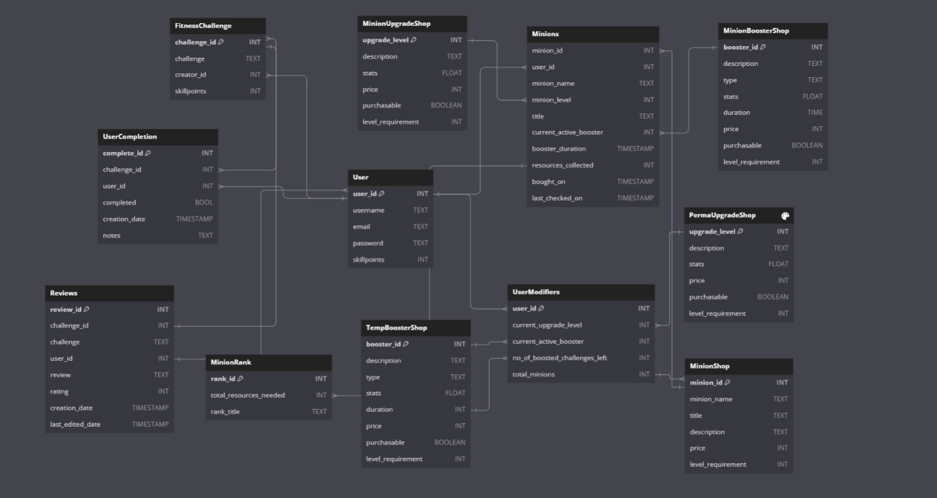

Video Demo
No. | Label | Screenshot
1 | Video Demo for Unregistered User | https://youtube.com/clip/UgkxCNhrM7_B1MxsG-5yMO7OHerhTrnTWO-9?si=AV5dlwlMHDvkunrT
2 | Video Demo for Login User  (From 0:58 to 8:23) | https://youtu.be/mawJxyBr2go
3 | Video Demo of all pages redirecting to currentChallenges if there is a current challenge | https://youtube.com/clip/Ugkxi6531kOHIPvwzn7glP8JwOQ49lqD8o_  F?si=eXCzXJHj4uitHBIO
4 | Video Demo of how upgrade and boosters increase skillpoints gain and drops boosted amount by 1 | https://youtube.com/clip/UgkxSnYWZw08gznBBp1r-nASiFtd2oNiugH8?si=c_GoA_692H2LC2vF

